**Introduction to Relational Database Concepts**

**Project 4 Specifications - 30 Points**

Background Information

The Highland Coffee Company is a service organization that provides coffee, tea and snacks to corporations. The company has hired you as their new business analyst to assist in developing queries that will provide information to management regarding its’ products, orders and sales reps. They want you to run some analysis reports for the months of October and November 2013.

Project Steps:

1. **Database Download and Setup (2 pts)** 
   1. Download the database from Blackboard. The name is: Project2xxx.accdb
   2. Rename the database **project4_XXX.accdb** where XXX is modified with your initials.
   3. Open the renamed database
   4. Open the SalesReps table
   5. Find the Sales Rep record with Last name = *Your_Name*
   6. Modify the Last name and First Name with your First name and Last Name
   7. Close the Sales Rep table
2. **Use the Query Designer SQL View to manually create the following queries.** 
   1. **Query #1 (3 points) – Basic SELECT Statement**Your manager needs a list of all customer “wins” from the city of Miami for the first 7 months of 2013. The company is trying to grow in the Miami area and want to determine how well the client base is growing.
      1. List the Customer Name, Email Address, City, State and Zip Code and phone number for Customers in the City of Miami with a service start date before 8/01/2013.
      2. Order your results by Customer Name ascending by Service Start Date ascending.
      3. Your result should include 8 rows. Compare your results to the results below.
      4. Save your result as **Customer_List_1**

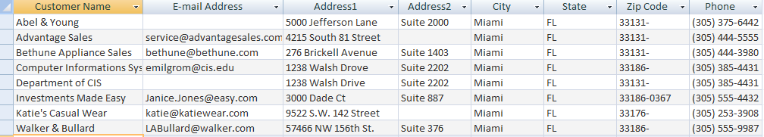

* 1. **Query #2 (5 points) – INNER JOIN Statement / BETWEEN Statement**The Sales department needs a detailed report of all sales and products for the month of October for customer **Abel & Young**. The customer is questioning their Invoice and we need to produce a list of all sales orders for October.
     1. List the Customer Name, Order Id, Order Date, Product Name and Quantity Ordered for all orders in October 2013 for Abel & Young.
        1. Use the table alias **PROD** for the products table.
        2. Use the **BETWEEN** clause to limit your rows to October 2013.
        3. Your result should include 4 rows. Compare your results to the results below.
        4. Save your result as **Customer_1_October_Sales_2**

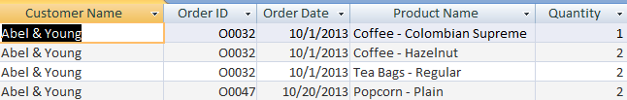

* 1. **Query #3 (5 points) – INNER JOIN / GROUP BY Statement / Field Expressions**The finance department needs a report to review sales volume for each of our clients for October and November.
     1. List the Customer Name, and Total dollar value for all orders for each customer.
        1. Use the GROUP BY clause to group your results by Customer Name,
        2. To determine the retail price for each item sold you should multiply the product cost * product markup.
        3. Sort your results by total order dollar value from highest to lowest.
        4. Your result should include 16 rows. Compare your results to the results below.
        5. Save your result as **Order_Sales_Summary_3**

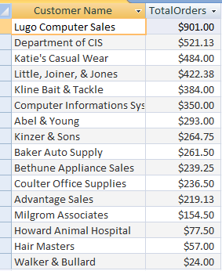

* 1. **Query #4 (5 points) OUTER JOIN / Field Expressions**The Sales department is doing a review of customers and wants to produce a list of all customers and their sales representative.
     1. List the Sales Rep ID Sale Rep Last Name, Sales Rep First Name and Customer Name and Customer ID For all Sales Reps.
        1. Include All Sales Reps, **even those without customers**.
        2. Create a field expression to combine the Sales Rep Last name and First Name into a single field. Separate the last Name and First Name with a comma. Call the Field “SalesRep”
        3. Sort your report by the the “SalesRep” field ascending order.
        4. Your report should end up with 18 rows. Compare your results to the results below.
        5. Save your Query as **Sales_Rep_Report_4**

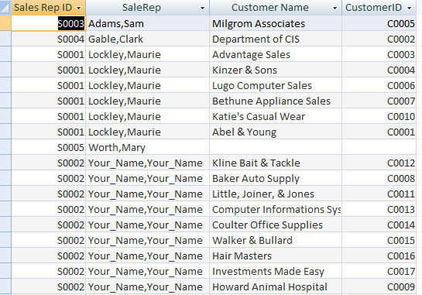

* 1. **Query #5 (5 points) GROUPING/ HAVING CLAUSE / SUB SELECT / Field Expressions**Sales and Marketing wants to know how many orders placed over the past 2 months have exceeded the average order size. They are considering a marketing campaign that targets customers with larger than average orders and want to determine which customers to target.
     1. List the Customer Name, OrderID and Total Order Amount for all orders that exceed the average order size.
        1. You will need to do a sub select to determine what the average order size is and use that for your comparison.
        2. Order your results from smallest to largest order amount.
        3. You must use a **HAVING CLAUSE WITH A SUBSELECT** to receive full credit.
        4. Your report should end up with 22 rows. Compare your results to the results below.
        5. Save your query as **Orders_Exceeding_Average_5**  
             
           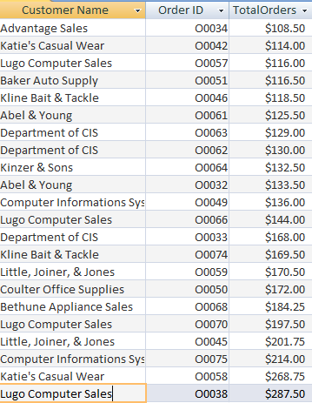
  2. **Query #6 (5 points) – Top N Query**Inventory Management is interested in seeing what the best selling products are over the past 2 months. This will help determine the appropriate re-order point settings set for the larger volume products.
     1. List the Product Name and Quantity Sold during the months of October and November 2013.
        1. You need to display only the top 2 selling products for the months of October and November for 2013.
        2. Order your results by QuantitySold in descending order to show the top 2 best selling products.
        3. Your query should return 2 rows. Compare your results to the results below.
        4. Save your query as **Top_Selling_Products_6**

